Samuel Hovland

CS 458-001

7 December 2022

Manual Testing: Scenarios and Behavior

Last updated 12 December 2022

**Introduction:** this document lists seven different situations that have been manually tested. The scenarios reflect subcases that have been recognized, and their observed behavior upon testing. More scenarios should be added if recognized. As of now, the only failed test is that if a course is added to the same semester as one of its prerequisites, the prerequisite error will be thrown. More information on that can be found below under the green-highlighted section.

**Courses move into schedule**

**Description**: courses dragged from category dropdown on academic planner to semester

boxes.

**Scenarios:**

1. **Course requires prerequisites before being added to semester:**
2. If course dragged to semester, but required prerequisite isn’t already in the semester:

Course added to semester, but the box is red. A warning tells which prerequisites

are required.

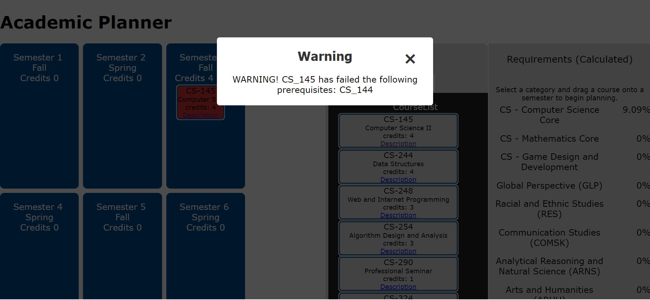

1. If course dragged to semester and required prerequisite already in previous semesters:

Course can be added to semester.

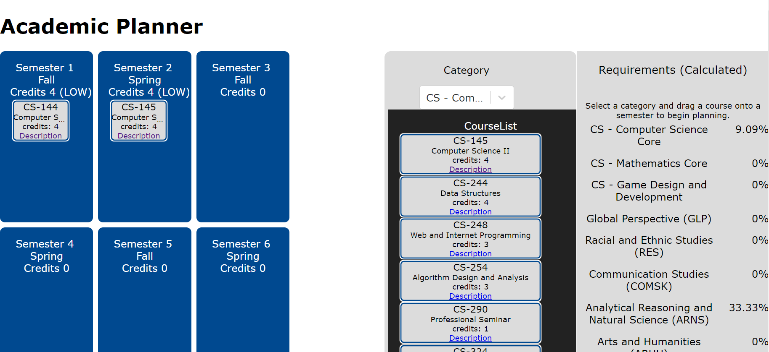

1. If course being dragged to semester requires prerequisite, and prerequisite is in a semester, but course requiring the prerequisite is placed in a semester before the prerequisite semester:

Course added to semester, but the box is red. A warning tells which prerequisites

are required.

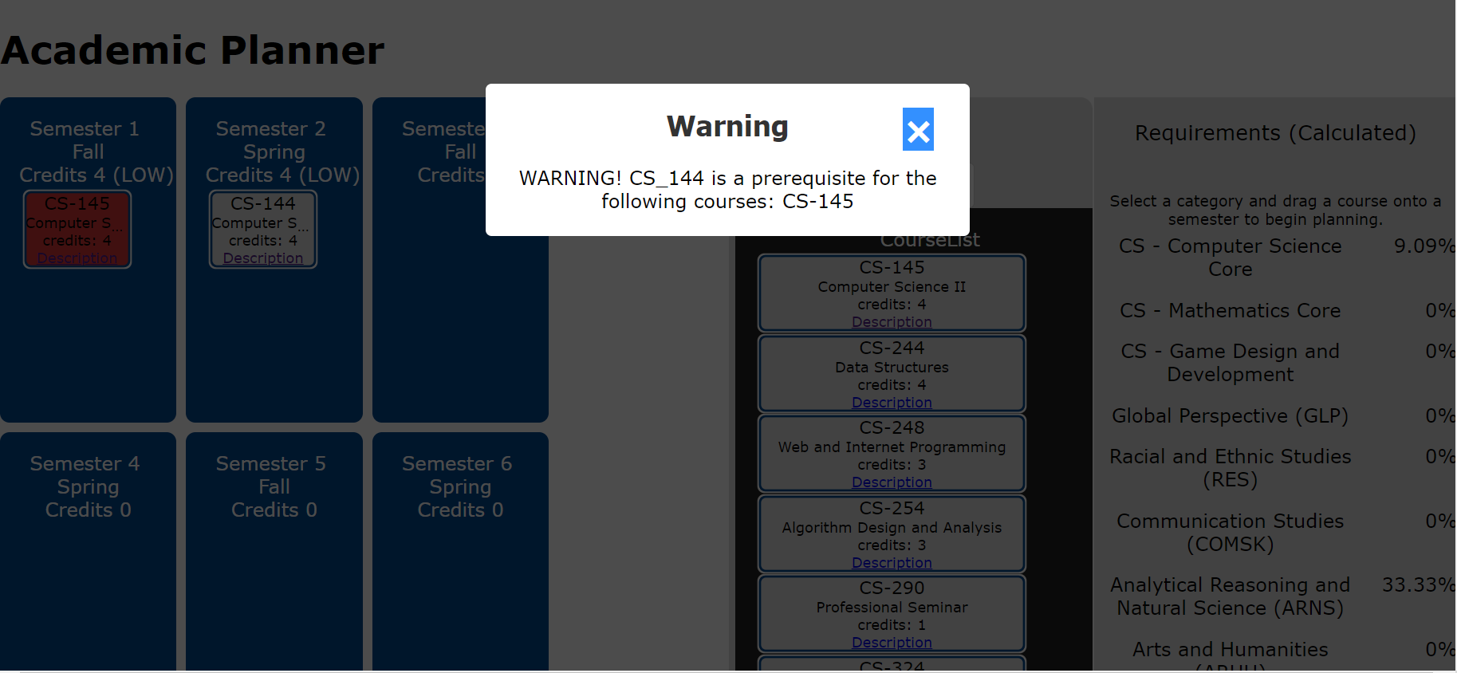

1. If course requiring prerequisite is added to the semester with its prerequisite:

Course added to semester, but the box is red. A warning tells which prerequisites

are required.

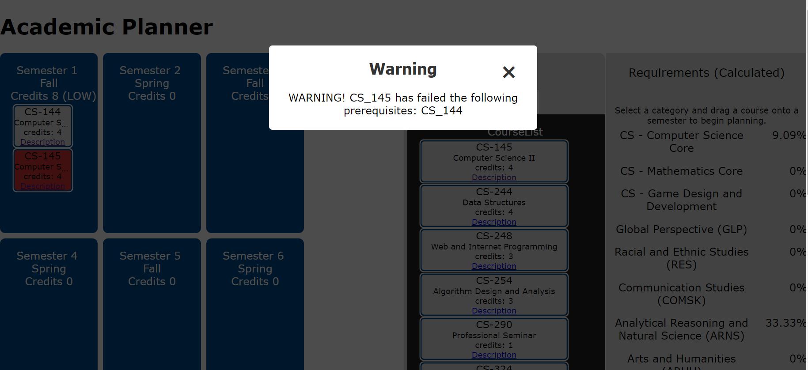

1. **Course does not require prerequisite before being added to semester boxes:**

a.) If courses successfully added to a semester: 1.

1.) If number of total credits below 12:

Number of credits displayed at top of semester box, “(LOW)” displayed near number of credits.

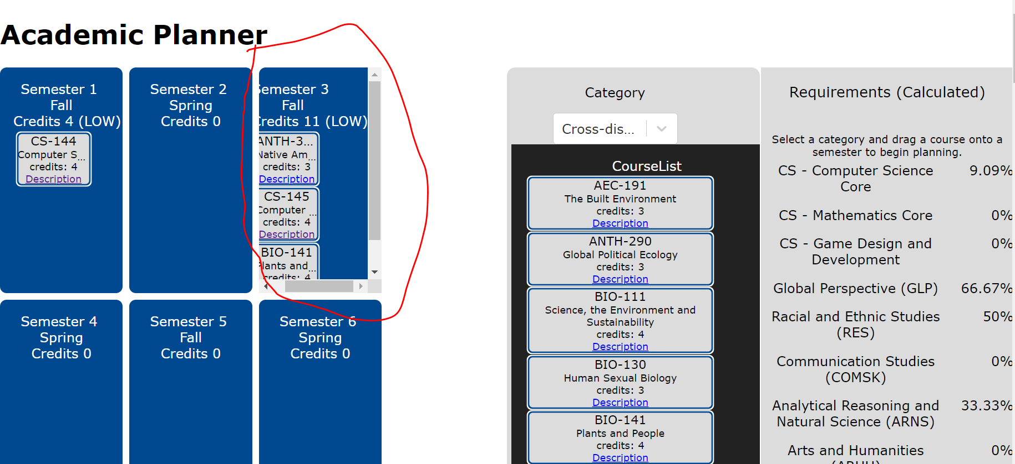

2.) If number of total credits above 18:

Number of credits displayed at top of semester box, “(HIGH)” displayed near number of credits.

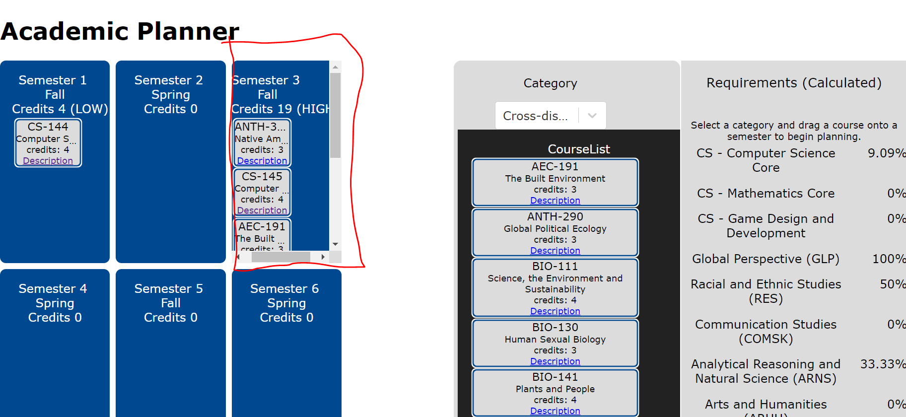

3.) If number of total credits is 0 or between 12-18:

Number of credits displayed at top of semester box, no warning displayed below number of credits.

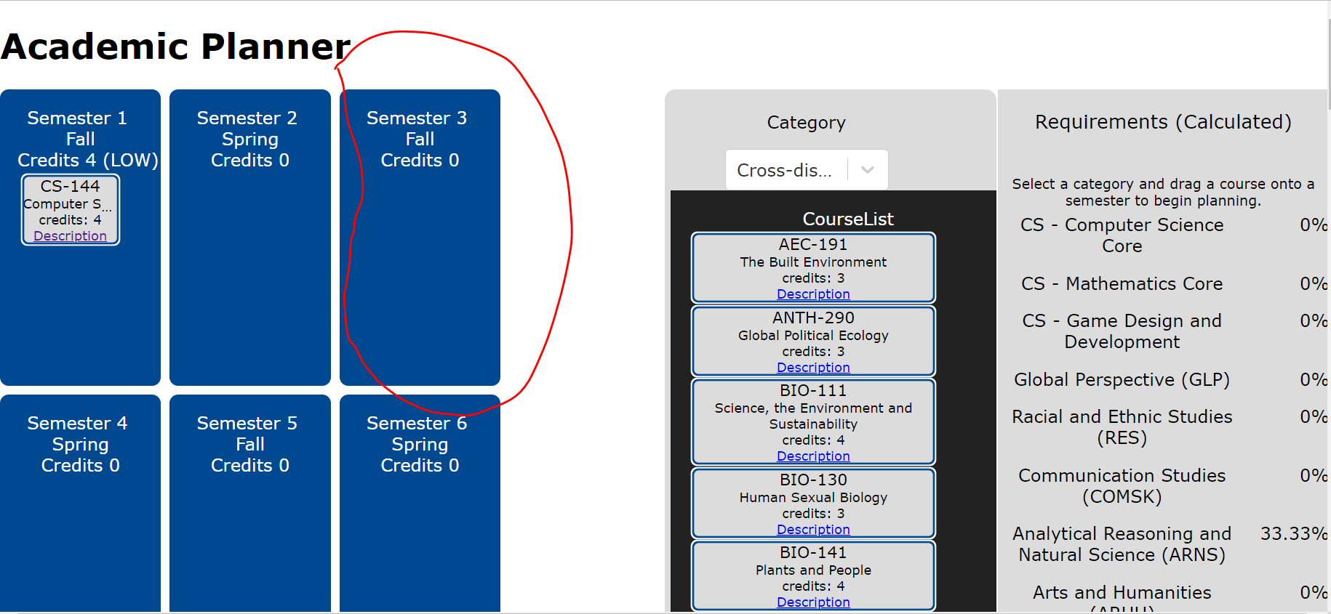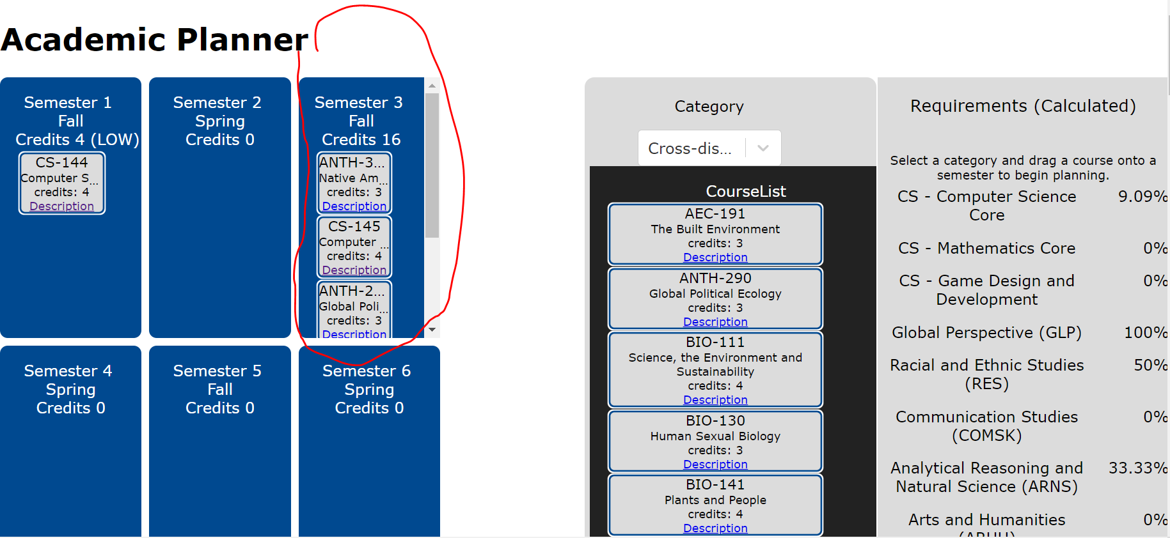

1. If attempt made to add course to a semester that already contains that course:

No warning displayed; course just can’t be added to same semester.

**Courses move out of schedule**

**Description:** courses in semester boxes dragged out of semester section and placed elsewhere.

**Scenarios:**

1. **Course dragged from category dropdown and dropped back into category dropdown:**

Course removed from semesters.

1. **Course dragged from semester boxes and dropped outside of that section, but not into category dropdown:**

Course remains in original semester.

1. **Course dragged and dropped from one semester to another:**

Course moves from original semester to the new semester.

**Courses move between semesters properly**

**Description:** courses already present in the semester boxes can be moved from one semester to another.

**Scenario:**

1. **Course dragged and dropped from one semester to another:**

Course moves from original semester to the new semester.

**You can add a course more than once, but there is a warning**

**Description:** attempting to add a course from the category dropdown to the semester boxes when that course is already present in at least one of the semester boxes.

**Scenario:**

1. **Course added to semester, but already exist in other semesters:**

Course added to semester, but the box is yellow. A warning tells that the course already exists in other semesters.

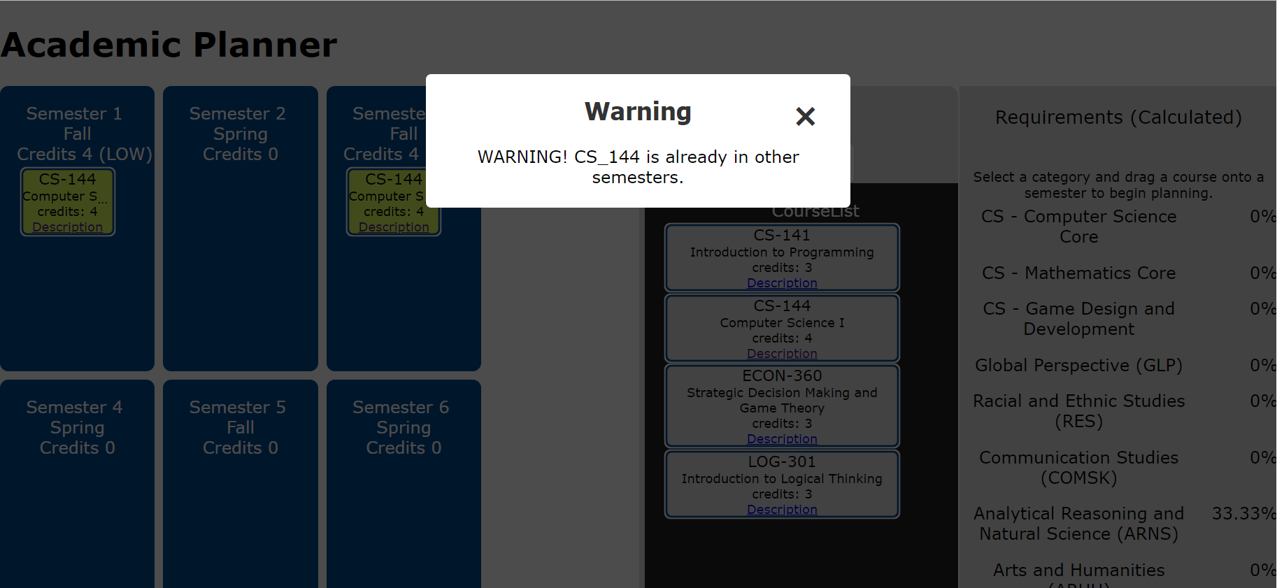

**Courses dragged from list to list do nothing**

**Description:** dragging a course from the course list, and immediately dropping it back in the course list.

**Scenario:**

1. **Course dragged from list and dropped in the list:**

Nothing happens.

**Prerequisite error messaging is accurate**

**Description:** message displayed when someone attempts to add a course to the semester boxes without the proper prerequisites.

**Scenario:**

1. **Prerequisite error triggered:**

Course added to semester, but the box is red. A warning tells which prerequisites

are required.



**Semester checking happens**

**Description:** system displays a warning if a course is added to a semester box if that course is already present in another semester.

**Scenario:**

1. **Course added to semester, but already exist in other semesters:**

Course added to semester, but the box is yellow. A warning tells that the course already exists in other semesters.

